Lateral Resource Guide
Avon Lake Regional Water is working hard to keep Lake Erie clean, but we need your help. Here’s the situation:
You likely have both your home’s dirty water and your clean water combining together into one pipe that takes your home’s water to the sewer under the street. By 2/1/18, you need to have those two types of water separated to keep your home’s clean water from getting into the sanitary sewer under your street.
Once we inspect, if you have work to do, you’ll likely have a choice to make. The two main options are (1) a gravity lateral and (2) a sump pump powering your storm lateral. Here’s a little more information on both options.
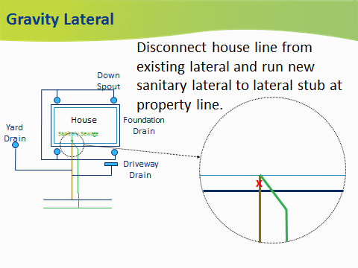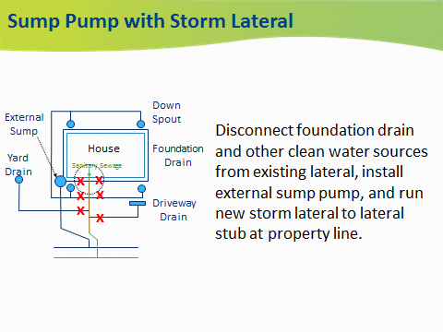
Once you decide which option is best for you, you are ready to get started. Here are some things to keep in mind as you start your project:
- Check avonlakewater.org or call our offices (440) 933-6226 to see which contractors are working with us.
- Contact your neighbors to join together and find a contractor who will give your group a good deal.
- Your contractor will need permits from us and possibly the City of Avon Lake (if it impacts your storm water drainage), but all permits will be free of charge.
- If your new lateral is ready before or when the new sewer line is complete, we will connect it for you for free.
- All wastewater laterals must be connected to the sanitary sewer no longer than one year after your sewer separation is complete.
- All homeowners will begin receiving sewer bill rebates once they connect both their laterals to their respective sewers.

